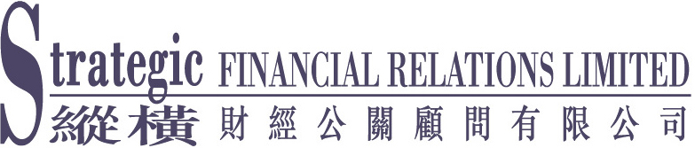

[For Immediate Release]

China Rare Earth Forms Strategic Alliance with General Electric

Kicks Off Close Collaboration

(25 February 2006 – Hong Kong) – Rare earth and refractory materials manufacturer China Rare Earth Holdings Limited (“China Rare Earth” or the “Group”) (stock code: 769) today announced that it has entered a strategic alliance agreement with General Electric Company (“General Electric”), one of the largest integrated business corporations in the world.

According to the agreement, China Rare Earth and General Electric will strengthen business collaboration. General Electric will increase order for various rare earth products from China Rare Earth to be used by its different subsidiaries in the manufacturing of products including medical equipment, lighting equipment and automobiles, etc. General Electric will also provide technical support to China Rare Earth. The move will facilitate the expansion of the scope of applications of rare earth.

Mr. Jiang Quanlong, Chairman of China Rare Earth, said, “We expect to reap huge synergistic benefits from the partnership with General Electric. Benefiting from the enormous demand from General Electric, which will use our products in a great variety of their products, we expect to see a strong boost in profit. Furthermore, with the technical support from General Electric, we will be able to extend the applications and production scale of our rare earth products, and in turn raise the quality of our products and our product development capabilities.”

About China Rare Earth Holdings Limited (Stock code: 769)

China Rare Earth Holdings Limited has been listed on the Stock Exchange of Hong Kong Limited since October 1999. The Group is engaged in the manufacture and sales of rare earth and refractory products. Rare earth products are widely applied in traditional industries including steel, metallurgy, construction, glass, and petrochemical, and high-tech industries such as electronics, communications, aerospace and medical equipment. Refractory products are used extensively in industrial refractory facilities for petrochemical, metallurgy, non-ferrous metallurgy, construction, glass, chemical fertilizers, ceramics and power industries, etc. For more information, please visit the company's web site at http://www.creh.com.hk.

- more -
China Rare Earth Holdings Limited
2006 Strategic Partnership with GE (Page 2)

The General Electric Company (NYSE:GE)

Established in America since 1878 and listed in 1896, General Electric has become one of the greatest corporations of integrated business in the world. GE operates in more than 100 countries and employs more than 300,000 people worldwide. Its business is diversified and comprised of technology, financial services, aircraft engineering, power generation, medical imaging, television programming and plastics. Their innovations honored the corporation with Nobel Prizes and numerous business awards throughout the years. For more information, please visit the company's web site at http://www.ge.com.

For press enquiries:
Strategic Financial Relations Limited
Joanne Lam / Anna Chan
Tel: 2864 4816 / 2864 4862
Fax: 2804 2789 / 2527 1196
Email: joanne@strategic.com.hk / anna.chan@strategic.com.hk
http:// www.strategic.com.hk

- end -

