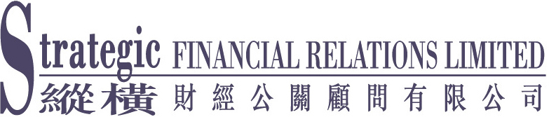

[For Immediate Release]

China Rare Earth Acquires Suhai Magnesium

at RMB 120 Million
* * *

Strengthens Supply Chain of Refractory Products

(28 December 2005 – Hong Kong) － Rare earth and refractory materials manufacturer China Rare Earth Holdings Limited (“China Rare Earth” or the “Group”) (stock code: 769) today announced that Yixing Xinwei Leeshing Refractory Materials Co., Ltd. (“Leeshing Refractory”) and Wuxi Xinwei High Temperature Ceramics Co., Ltd. (“High Temperature Ceramics”), both are wholly owned subsidiaries of the Group, entered into the equity transfer agreement dated 23 December 2005 with two independent parties, Ms Jin Yefang and Mr Liu Yonggang, to acquire the entire equity interest in Haicheng City Suhai Magnesium Ore Co., Ltd. (“Suhai Magnesium”) at a total consideration of RMB120 million (approximately HK$115.4 million) (“Acquisition”).

The purchase price is to be paid in cash by Leeshing Refractory and High Temperature Ceramics and will be funded by internal resources of the Group. Upon completion of the Acquisition, Suhai Magnesium became a wholly owned subsidiary of the Group, and is now held as to 70% by Leeshing Refractory and 30% by High Temperature Ceramics.

Suhai Magnesium is a domestic limited liability enterprise established in Haicheng, Liaoning Province, the PRC. It is principally engaged in the manufacture and sale of magnesium grains and related materials. Suhai Magnesium is a supplier of the Group, supplying fused magnesium grains which is a major raw material for the production of refractory products.

Mr. Jiang Quanlong, Chairman of China Rare Earth, said, “This acquisition is a major strategic move in our bid to establish a vertical industrial chain. It presents clear synergistic benefits for our operations, as we will be able to secure supply of fused magnesium grains as well as reduce the cost of sales of refractory products by consolidating the production of downstream and upstream products in the Group.”

- more -
China Rare Earth Acquires Suhai Magnesium at RMB 120 Million (Page 2)

As at 31 December 2004, the values of the total assets and the net assets of Suhai Magnesium (computed under the PRC GAAP) amounted to approximately RMB73.6 million (approximately HK$70.8 million) and approximately RMB29.9 million (approximately HK$28.8 million) respectively. For the two years ended 31 December 2004, the net profit (before taxation and extraordinary items) of Suhai Magnesium (computed under the PRC GAAP) amounted to approximately RMB13.2 million (approximately HK$12.7 million) and approximately RMB31 million (approximately HK$29.8 million) respectively; whereas for the same periods, the net profit (after taxation and extraordinary items) of Suhai Magnesium (computed under the PRC GAAP) amounted to approximately RMB8.8 million (approximately HK$8.5 million) and approximately RMB20.8 million (approximately HK$20 million) respectively.

- end -

About China Rare Earth Holdings Limited
China Rare Earth Holdings Limited has been listed on the Stock Exchange of Hong Kong Limited since October 1999. The Group is engaged in the manufacture and sales of rare earth and refractory products. Rare earth products are widely applied in traditional industries including steel, metallurgy, construction, glass, and petrochemical, and high-tech industries such as electronics, communications, aerospace and medical equipment. Refractory products are used extensively in industrial refractory facilities for petrochemical, metallurgy, non-ferrous metallurgy, construction, glass, chemical fertilizer, ceramics and power industries, etc.

For press enquiries:
Strategic Financial Relations Limited
Joanne Lam / Sandra Tsui
Tel: 2864 4816 / 2864 4824
Fax: 2111 9030 / 2804 2789
Email: joanne@strategic.com.hk / sandra@strategic.com.hk
http:// www.strategic.com.hk

